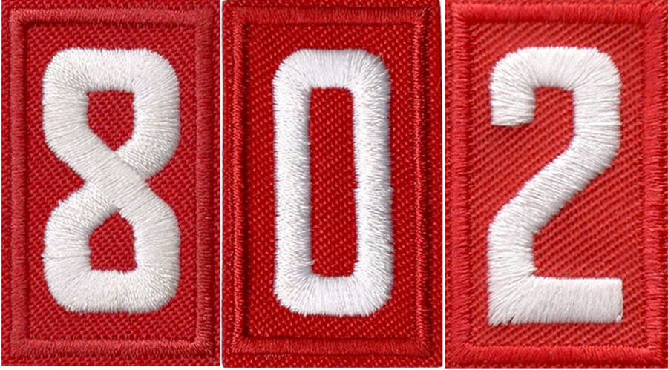
Holiday Fellowship
Aberdeen, MD

Fairbrooke Senior Apartments
  - 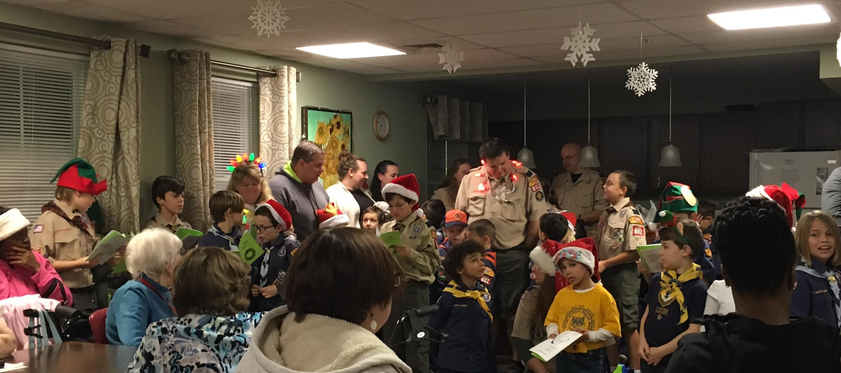
  - Tuesday, 17 December 2019
  - 6:30-7:30pm
Join Cub Scouts from Pack 802 as we gather with residents of the Fairbrooke Senior Apartments to share in fellowship, holiday songs, and festive treats.
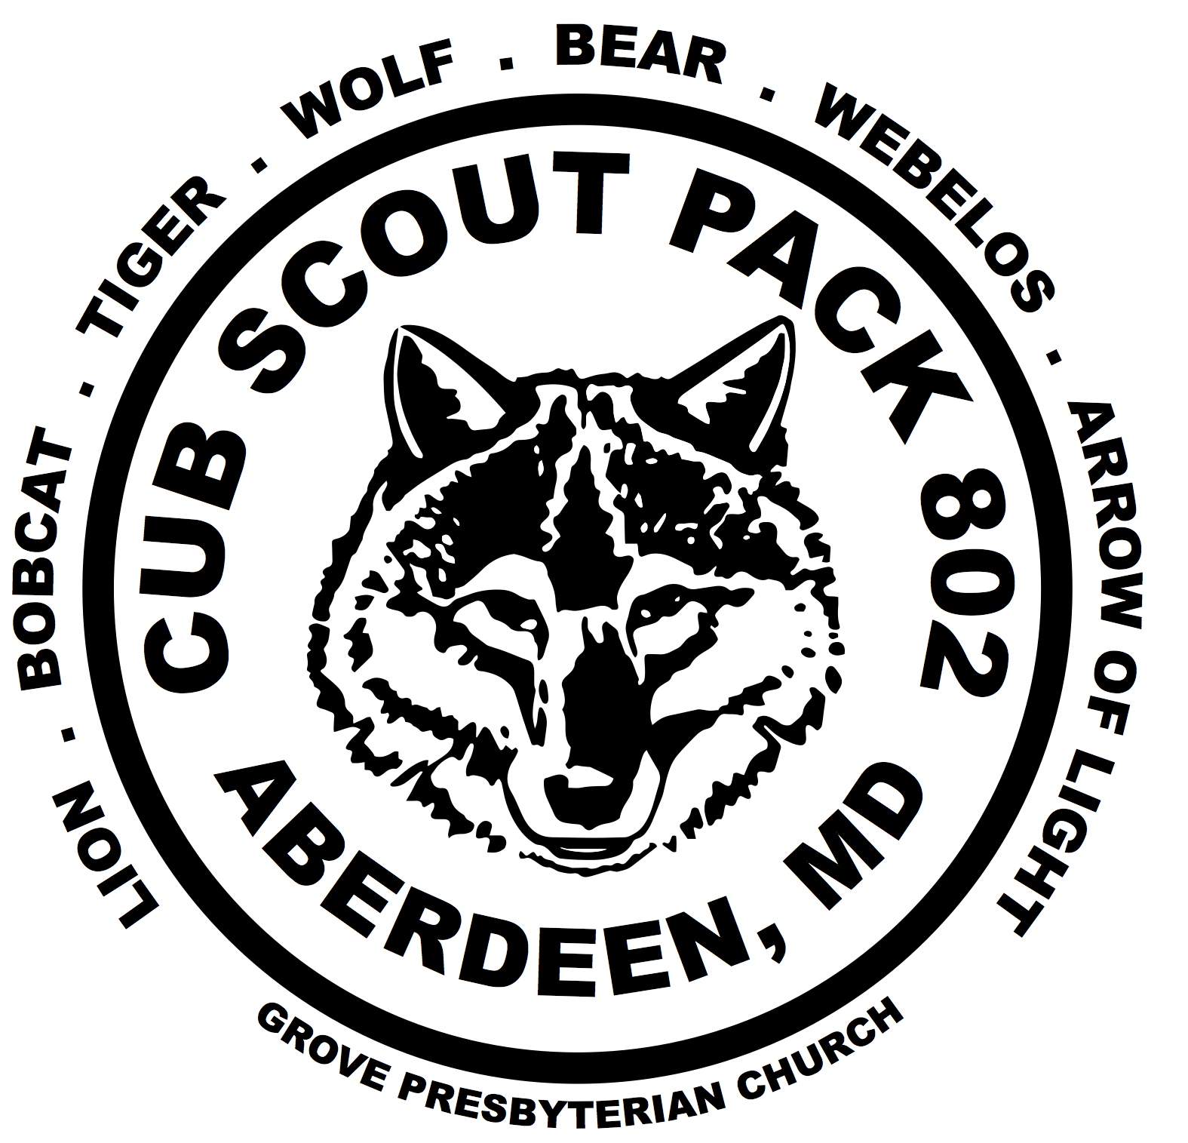
  - Location: 700 W Bel Air Ave, Aberdeen, MD 21005
Cub Scout Pack 802
Grove Presbyterian Church
50 E. Bel Air Avenue
Aberdeen, MD 21005
http://Pack802md.com

